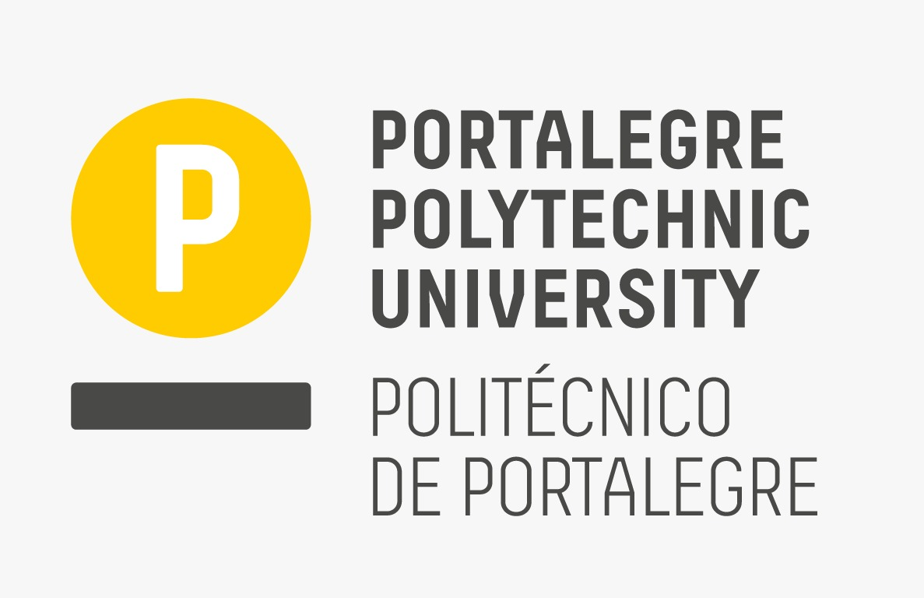

ICDAM-2024
5th International Conference on Data Analysis and Management

Organized by London Metropolitan University, London, UK (Venue Partner)

in association with

WSG University, Bydgoszcz, Poland, Europe

&

Portalegre Polytechnic University, Portugal, Europe

&

BPIT, GGSIPU, Delhi

Date: 14th - 15th June 2024

************** CALL FOR PAPERS ***************

SPECIAL SESSION ON
[ INSERT SEPCIAL SESSION NAME]

SESSION ORGANIZERS:
[ INSERT ORGANIZERS NAME WITH AFFILIATION & EMAIL ID]
EDITORIAL BOARD: (Optional):
[Name, University or Organization, Country, e-mail]

SESSION DESCRIPTION:
[INSERT THE SCOPE OF THE SESSION IN FEW LINES]

RECOMMENDED TOPICS:
Topics to be discussed in this special session include (but are not limited to) the following:

- [Please insert a minimum of 6 topics]

SUBMISSION PROCEDURE:
Researchers and practitioners are invited to submit papers for this special theme session on [INSERT SESSION NAME on or before INSERT DATE ] . All submissions must be original and may not be under review by another publication. INTERESTED AUTHORS SHOULD CONSULT THE CONFERENCE’S GUIDELINES FOR MANUSCRIPT SUBMISSIONS at https://icdam-conf.com/downloads . All submitted papers will be reviewed on a double-blind, peer-review basis.

NOTE: While submitting a paper in this special session, please specify [SESSION NAME] at the top (above paper title) of the first page of your paper.

* * * * * *

